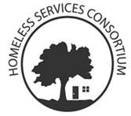

**Core Committee Agenda**

October 18, 2018 1pm-3pm, United Way, Board Room A

1. Race and the Housing Priority List
2. CoC NOFA To Do List
3. Review and Discuss CoC Membership Application
4. Next meeting November 1, 2018: Location?
   1. Affirmative Marketing Plan
   2. Housing Navigation Services
   3. Performance Spreadsheet